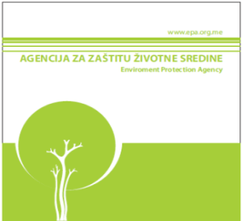
MONTENEGRO

ENVIRONMENTAL PROTECTION AGENCY

Pursuant to Articles 8 and 12 of the Decree on Limit Values of Pollutants in Liquid Fossil Fuels (Official Gazette of Montenegro 39/10 and 43/2010) the first Programme for Monitoring of the Quality of Liquid Fossil Fuels developed based on the standard MEST EN 14274 was completed in 2011/12. The Programme covered motor petrol (BMB 98 and BMB 95) and diesel fuel. The total number of samples was determined based on the selection of the statistical model C within the standard MEST EN 14274 and the factor of variability of the fuel quality in Montenegrin market.
Sampling and laboratory analysis were carried out by the authorised legal entity, accredited in line with the standard MEST ISO/IEC 17025.
Out of the sampling number defined by the Programme (total of 300), 291 samplings and analyses were completed. The review of planned and completed activities is presented in the Table below.

FUEL TYPE |  | PLANNED NUMBER OF ANALYSES | NUMBER OF COMPLETED ANALYSES | TOTAL PLANNED | TOTAL COMPLETED | PERCENTAGE OF COMPLETION  %
Petrol | BMB-95 | 100 | 98 | 300 | 291 | 97
 | MB-98 | 100 | 93
Diesel | Petrol stations | 80 | 80
 | Reservoirs | 20 | 20

The reason why 3% of analyses failed to be completed is non-existence of an updated database with the Energy Regulatory Agency related to the type of fuel that suppliers distribute on petrol stations in Montenegro. Based on the field visit by environmental inspection during the carrying out of the monitoring programme of liquid fossil fuels for 2011, the list of suppliers was updated, and it was used in the course of preparation of the Programme of monitoring the quality of liquid fossil fuels for 2012.

Based on the analysis of the findings from the report on examination of the quality of fuel that we are enclosing, the conclusion is that all examined samples of liquid fossil fuels were in line with the Decree on Limit Values of Pollutants in Liquid Fossil Fuels (Official Gazette of Montenegro 39/10).

Director
Daliborka Pejović

